**Assignment 1: Implement a navigation bar using an unordered list with links to different sections of your HTML page. Use CSS to style the list as a horizontal menu and highlight the current page or section.**

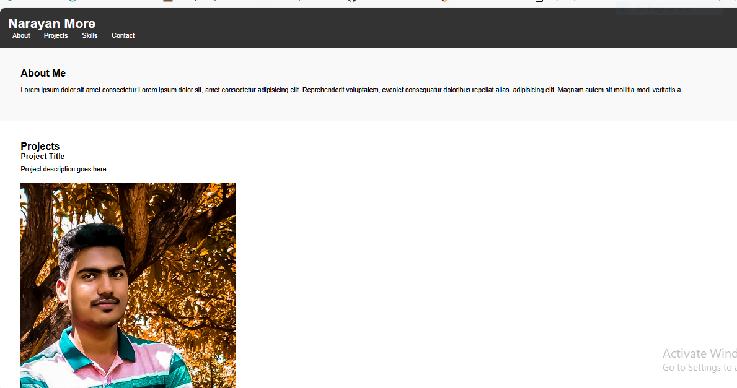

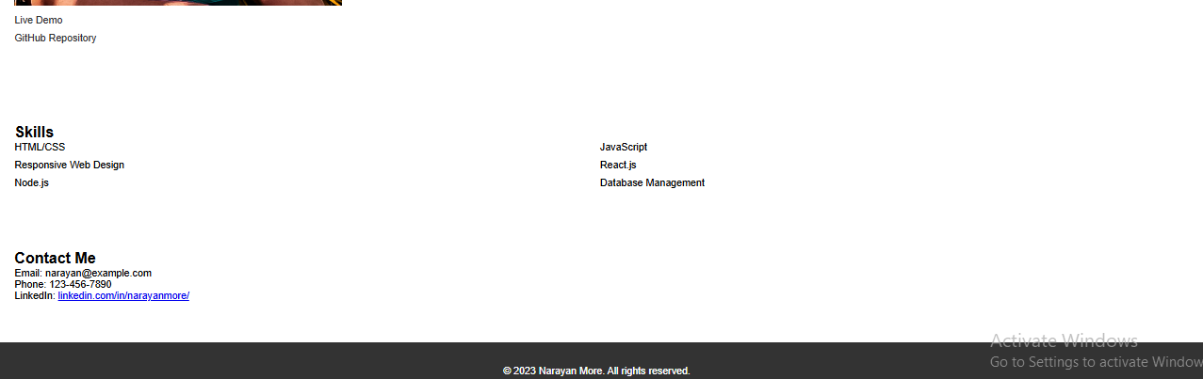

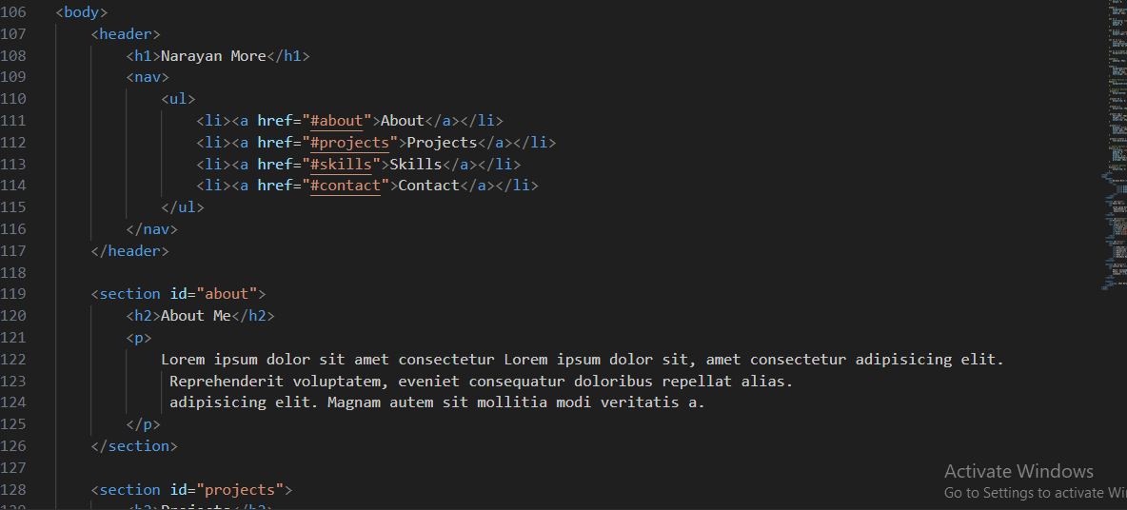

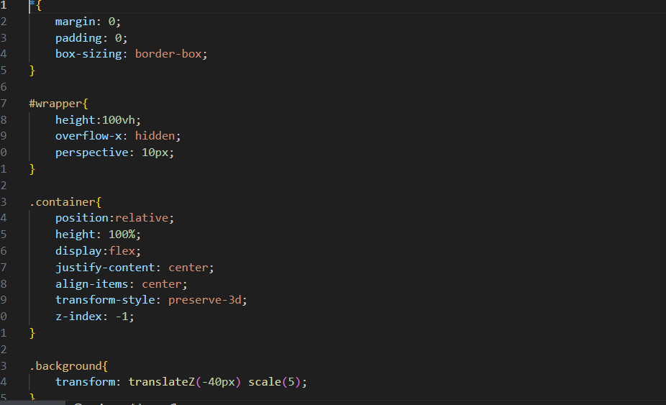

**Assignment 2: Create a simple HTML page that includes the use of headings, paragraphs, and at least two semantic tags like <article> or <section>. Add a table with data of your choice and a form with fields for a user's name, email, and a submit button.**

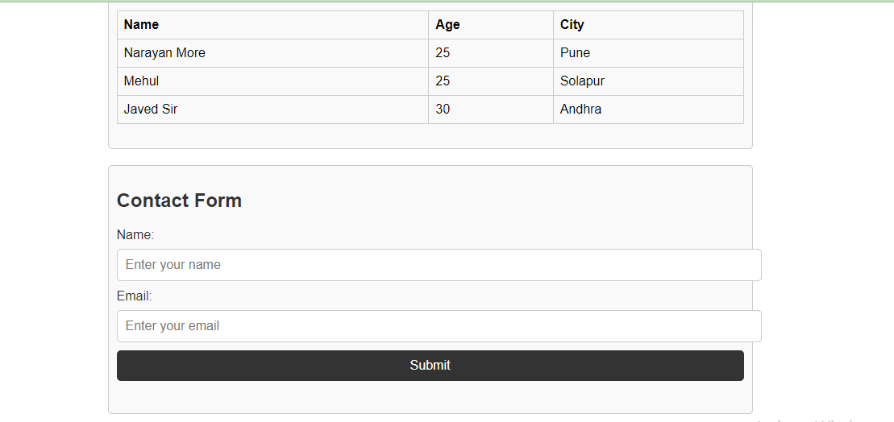

**<table>**

**<thead>**

**<tr>**

**<th>Name</th>**

**<th>Age</th>**

**<th>City</th>**

**</tr>**

**</thead>**

**<tbody>**

**<tr>**

**<td>John Doe</td>**

**<td>30</td>**

**<td>New York</td>**

**</tr>**

**<tr>**

**<td>Jane Smith</td>**

**<td>25</td>**

**<td>Los Angeles</td>**

**</tr>**

**<tr>**

**<td>Michael Johnson</td>**

**<td>35</td>**

**<td>Chicago</td>**

**</tr>**

**</tbody>**

**</table>**

**</section>**

**<section>**

**<h2>Contact Form</h2>**

**<form action="#" method="post">**

**<label for="name">Name:</label>**

**<input type="text" id="name" name="name" placeholder="Enter your name" required>**

**<label for="email">Email:</label>**

**<input type="email" id="email" name="email" placeholder="Enter your email" required>**

**<input type="submit" value="Submit">**

**</form>**

**</section>**

**Assignment 3: Apply the CSS box model to ensure that your page content has appropriate margins and padding. Create a layout using div tags and style them to arrange content in a multi-column format using floats or flexbox.**

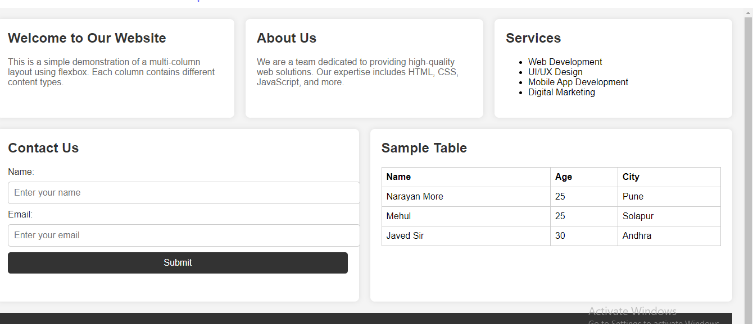

**When we wreap:**

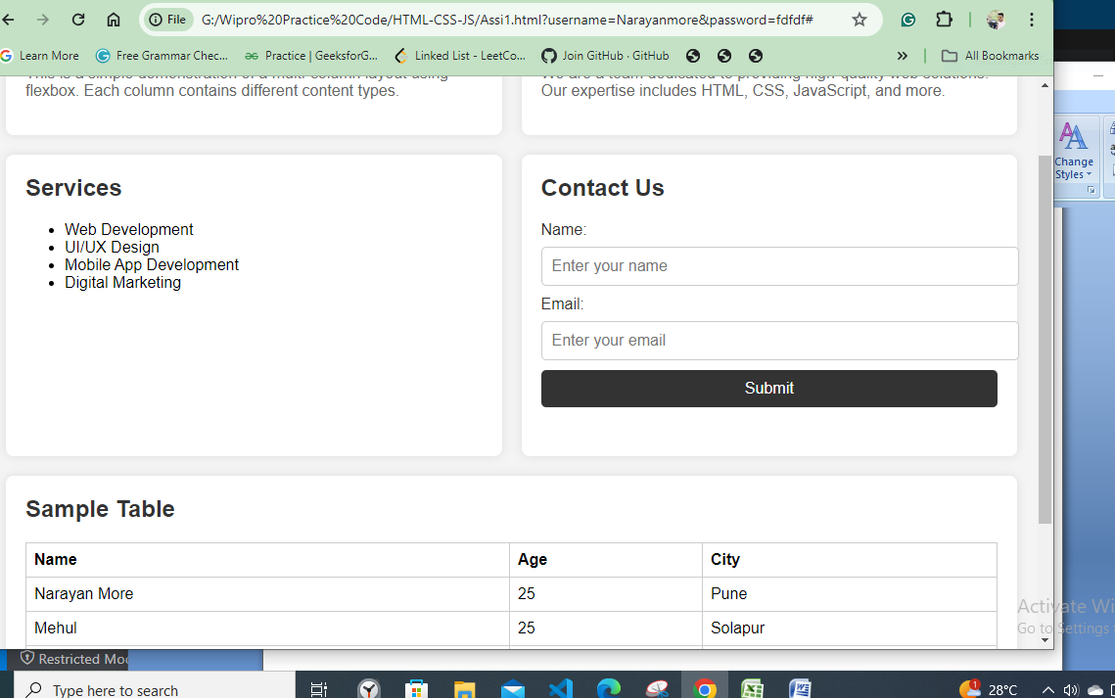

**When we fully Wreap:**

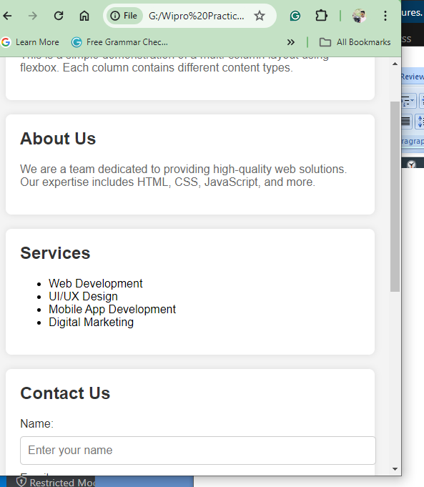

**Ths is all laptop, tab, mobile view:**

**Assignment 4: Enhance the page by adding CSS3 animations to the menu and form elements. Also, use media queries to make the page responsive, ensuring it looks good on both desktop and mobile screen sizes**

CSS Enhancements:

* Column Animation: Added a subtle animation (transform and box-shadow) on hover to create a lifting effect.
* List Styling: Styled the <ul> list items with custom bullet points.
* Form Transitions: Added transitions to input fields for a smooth visual feedback (border-color change).
* Responsive Design: Used media queries (@media) to adjust the layout for smaller screens (mobile devices). Columns stack vertically and occupy full width on screens narrower than 768px.

/* Responsive design */

@media (max-width: 768px) {

.container {

flex-direction: column;

}

.column {

flex: 1 1 100%;

margin-bottom: 20px;

}

}

• Columns in the .container flexbox layout stack vertically on smaller screens to maintain readability and usability.

• Input fields and buttons adjust their width and spacing appropriately for different screen sizes.

**Assignment 5: Take the static HTML page from Day 1 and integrate Bootstrap. Refactor the navigation bar, table, and form to use Bootstrap components. Ensure the page is responsive using Bootstrap's grid system.**

• Bootstrap Integration:

* Navbar: Utilized Bootstrap's navbar component for a responsive navigation bar. The navbar-expand-md class ensures it collapses on smaller screens.
* Grid System: Sections (<section>) within the container class are responsive due to Bootstrap's grid system.
* Form: Refactored <form> using Bootstrap's form-group and form-control classes for better styling and responsiveness.
* Table: Enhanced <table> with table, table-striped, and table-responsive classes to improve readability and handle small screens.

• CSS and JS:

* Linked Bootstrap CSS and JS files from CDN (Content Delivery Network) for styling and functionality.
* Added custom styles in <style> tags for additional adjustments like body padding and footer styling.

• Responsive Design:

* Used Bootstrap's grid classes (container, row, col-*) to ensure content adjusts to different screen sizes (md and below).
* Ensured the navbar collapses into a toggleable menu on smaller screens (navbar-toggler).

• Accessibility:

* Maintained semantic HTML structure with <section> for content areas and <nav> for navigation.
* Ensured form inputs have appropriate labels (for attribute) for accessibility.